This document is instructions for Drupal 8 only, for Drupal 7 please see the media recipe

Inserting button for Media Library in CKeditor
- Install and enable the module Media Library. This module is required by Media Entity Browser(Media Library). After the installation, a Media Library view is created.
- Install and enable the Media Entity Browser (Media Library) Module. This module requires the Inline Entity Form, Entity Browser, Entity Browser IEF modules.
- Install and enable the Embed Entity module. This allows any entity to be embedded in CKEditor
- Install and enable the Embed module. With this module, we can Add a button in CKEditor for entity embedding.
  - Once this module is installed, goto Configuration->Content Authoring->Text Editor Embed button to add a new button (/admin/config/content/embed/button/add)
  - Put the label : Image from the Media Library
  - Select Embed Type: Entity
  - Select Entity type: Media
  - Select Media type: Image
  - Allowed Entity Embedded Display plugins: Media library
  - Choose Media Entity Browser (Media Library) for Entity browser
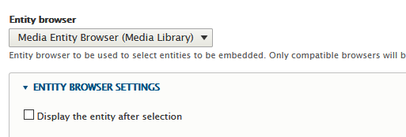
  - Chose a button for your ckeditor:
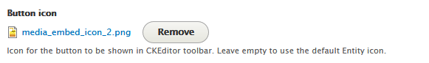
This is what it looks like before saving
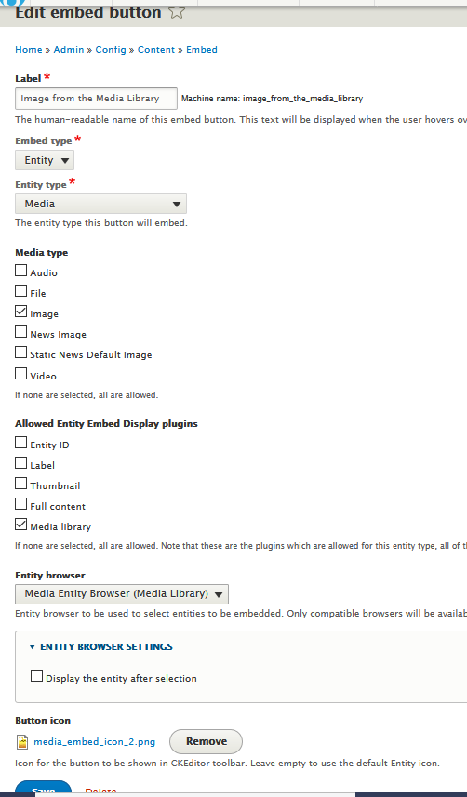
After saving, the added button is shown as follow. the Node Entity button is automatically added to your CKEditor
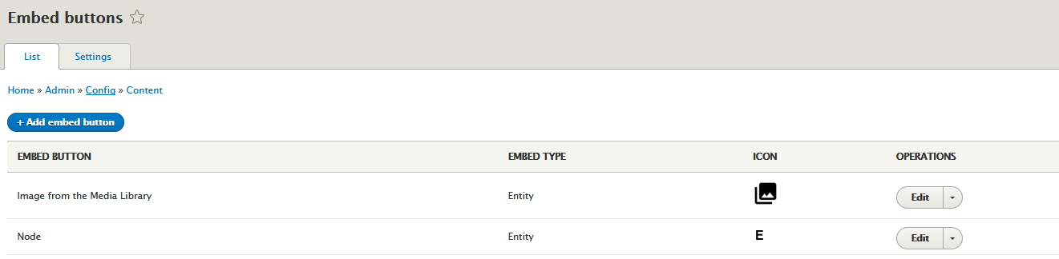Configure your CKeditor for text formats and editor
      - Goto Configuration->Content Authoring->Text formats and editors
      - Select your CKEditor (Basic Html) and click on configure
      - Move the new button just you created to the active toolbar
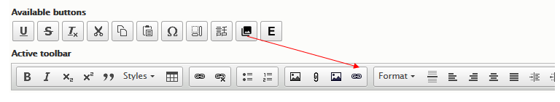
      - Enable filter for Display Embedded entities
      - Move Display embedded entities unders Caption images
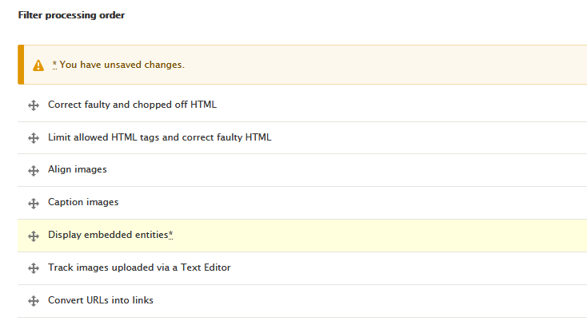

      - Add the following tag in Allowed HTML tags
<drupal-entity data-entity-type data-entity-uuid data-entity-embed-display data-entity-embed-display-settings data-align data-caption data-embed-button alt title>
Testing:
- Create a content (Basic page for example) to test the functionality for the new added button
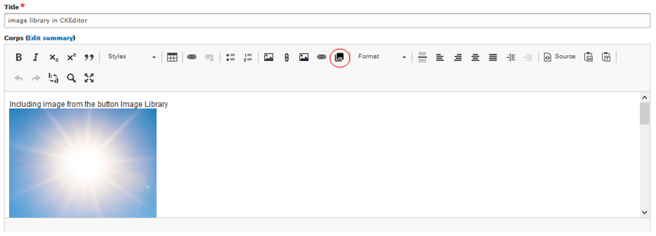
      - Click on the icon highlighted on red (image from Media Library), the following modal popup will display


